Project Development Phase Sprint 4

|  |  |
| --- | --- |
| Team ID | PNT2022TMID13652 |
| Project Name | Smart waste management system for  metropolitan cities |
| Maximum Marks | 8 Marks |

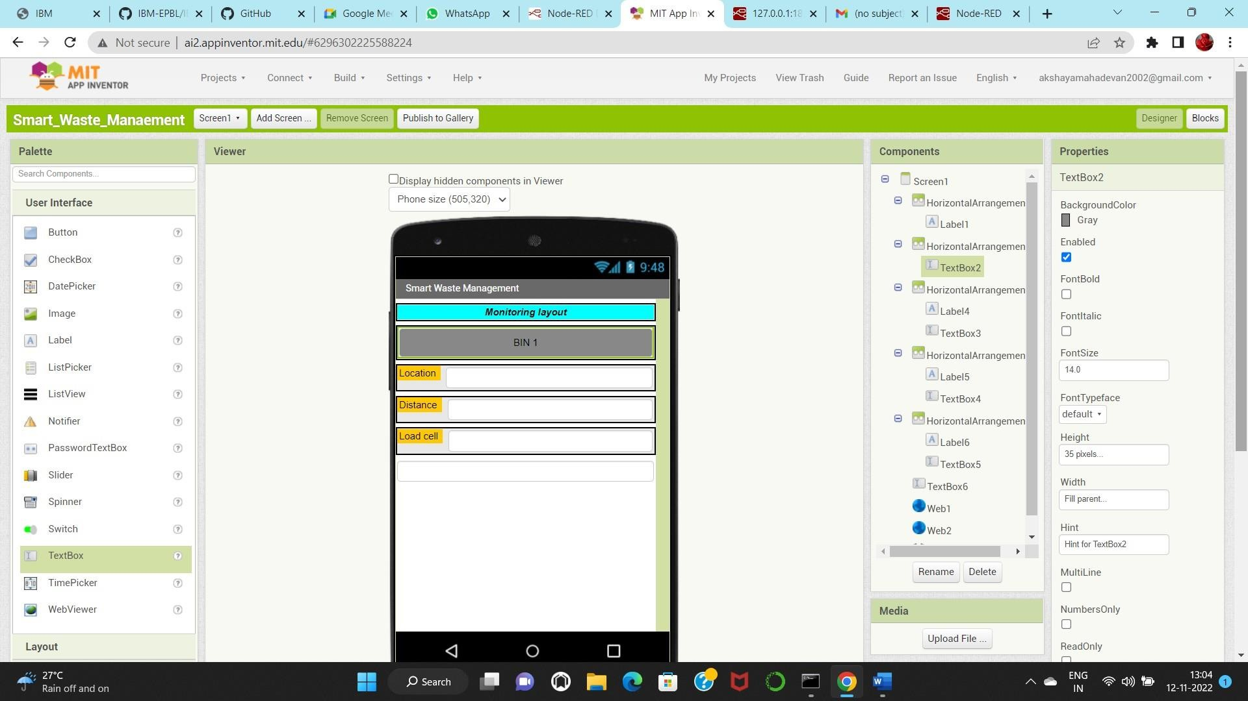**MIT - WEBPAGE DESIGN WINDOW:**

**BACKEND NODE RED FLOW CONNECTION:**

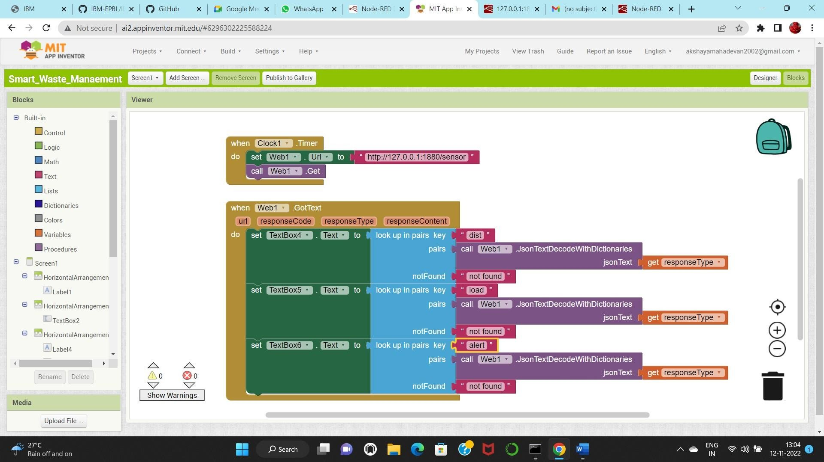

**QR CODE:**

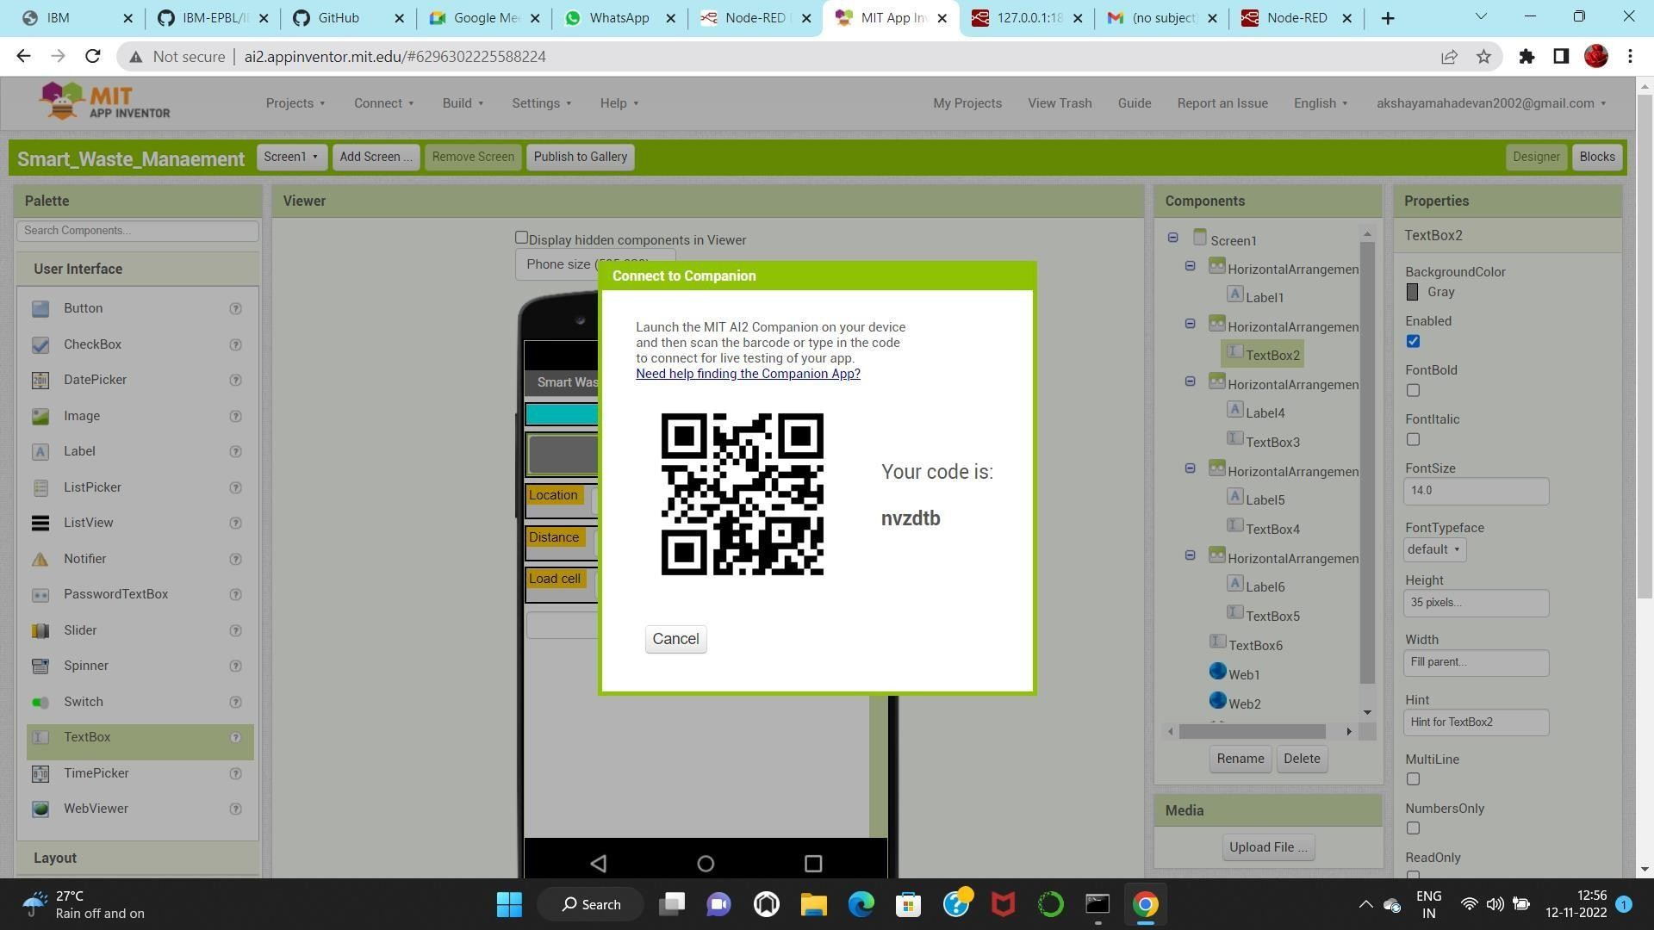

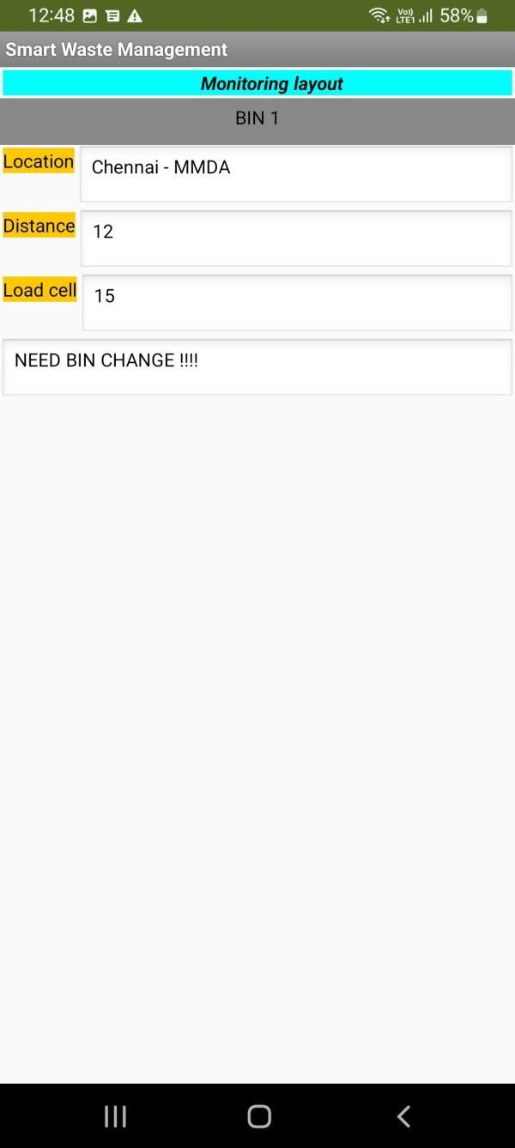**OUTPUTS IN MOBILE:**

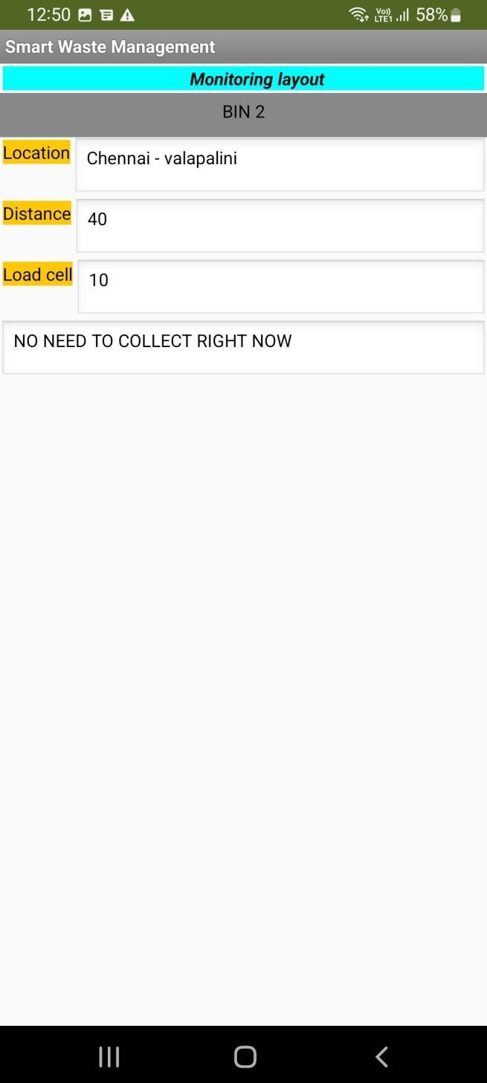

**CONCLUSION:**

In sprint 4 we have created web application in MIT APP INVENTOR using NODE RED FLOWS in the backend and web interface in designed as per need. Output is seen is mobile by scanning the code generated by MIT APP INVENTOR. Thus the smart waste management for metropolitan cities was created and the output was verified.